Trip Report
Australian Animal Health Laboratory, CSIRO – Geelong, AU
10-11May2017

I visited CSIRO’s Australian Animal Health Laboratory over May 10^{t, h} & 11th. Mark Tizard was a gracious host who arranged a tour inside the containment areas (including the large animal facility) and introduced me to the director, business coordinator, and several key scientists involved in animal research and containment. As there are sensitivities to the facility around security, I will not give much detail, but the AAHL is engineered well and driven by protocols that will enable containment of strain maintenance, reproductive, and mate choice experimentation for GBIRd and/or DARPA purposes. The facility maintains animal laboratories rated at the Physical Containment (PC) levels 2-4 (equating to Animal Biosafety Levels (ABSL) 2-4 for US equivalent.

Key aspects:
- Well established containment laboratory/facility with decades of experience in animal containment assurance.
- Decades of operations, and all animals accounted for (contained).
- Various levels of animal containment – PC2-PC4. Equates to ABSL4
- The containment facility has a box within a box within a box design.
- Showers are required upon exit and all items that go in, must stay in or get autoclaved/incinerated prior to exit.
- All doors are sealed with a bubble seal around the door.
- A virtual tour is available, though it would need to be arranged with a special video link.
- Some physical adjustments to the laboratory would be necessary if research needs required non-standard mouse cage situations.
  - Pens could be constructed and rooms retro-fitted if space required
- Laboratory space is currently available if/when needed.

For publicly available info:
https://www.csiro.au/en/Research/Facilities/AAHL/
https://www.csiro.au/en/Research/Facilities/AAHL/AHHL-Infrastructure/Engineering-underpinning-the-science
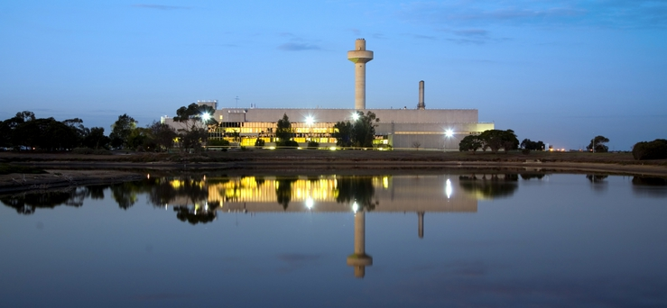

CSIRO'S AUSTRALIAN ANIMAL HEALTH LABORATORY, GEELONG, VICTORIA
The Australian Animal Health Laboratory (AAHL) is a national centre of excellence in disease diagnosis, research and policy advice in animal health. AAHL is a major facility of CSIRO Livestock Industries. The facility plays a vital role in maintaining the health of Australia’s livestock, aquaculture species and wildlife.
AAHL opened in 1985 at a cost of over A$150 million, and is one of the most sophisticated laboratories in the world for the safe handling and containment of animal diseases.
Major diseases of livestock, aquaculture animals, and wildlife, are studied. AAHL includes a high-biocontainment facility, to safely fulfil its major role of diagnosing emergency animal disease outbreaks. Within the high biocontainment facility, AAHL contains modern animal facilities that can house a range of animal species up to biosecurity level four (BSL4), the highest level available.
Image and text from: http://www.scienceimage.csiro.au/library/animals/i/10698/csiro-s-australian-animal-health-laboratory-geelong-victoria/16

